**Deliverable 3: Process Modeling**

Group Name: WebIt

Group Members: Theresa Tomilson, Krishna Viradia, Mehak Uddin, Sara Nazir, Courtney Burns, Nuri Surur, Wubnyonga Tete

Class Name: IS 436 - Structured Systems Analysis and Design

Due Date: 4/17/2019

**Deliverable 2 use case**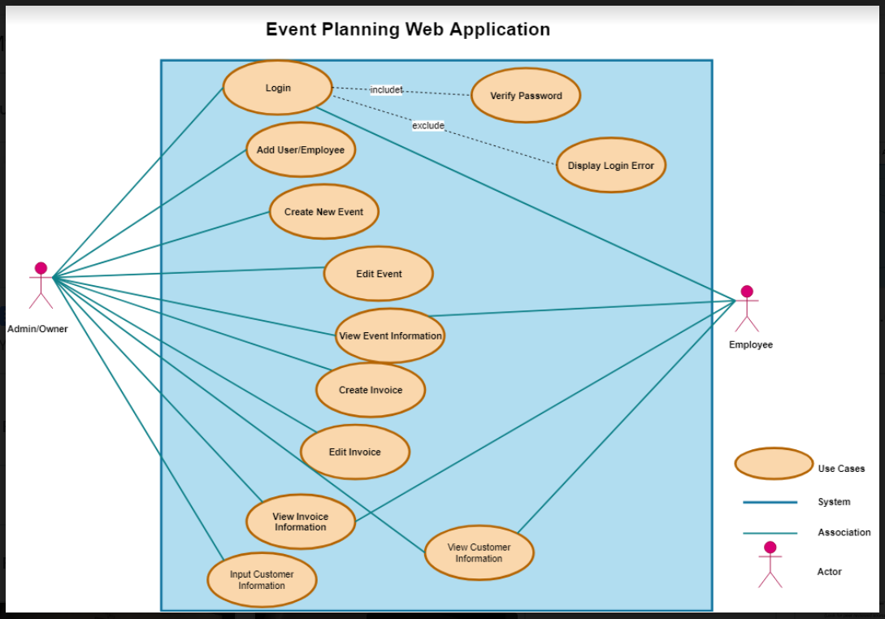

**Deliverable 3 use case**

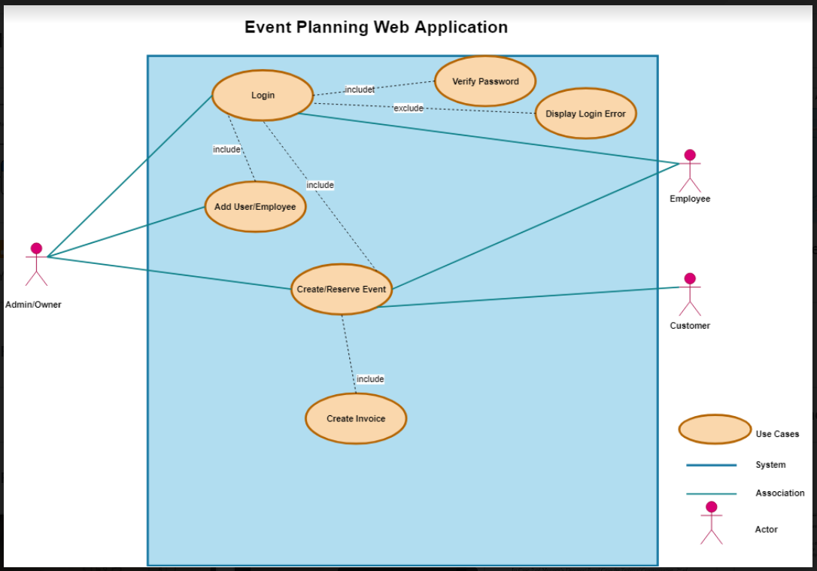

**CONTEXT DIAGRAM**

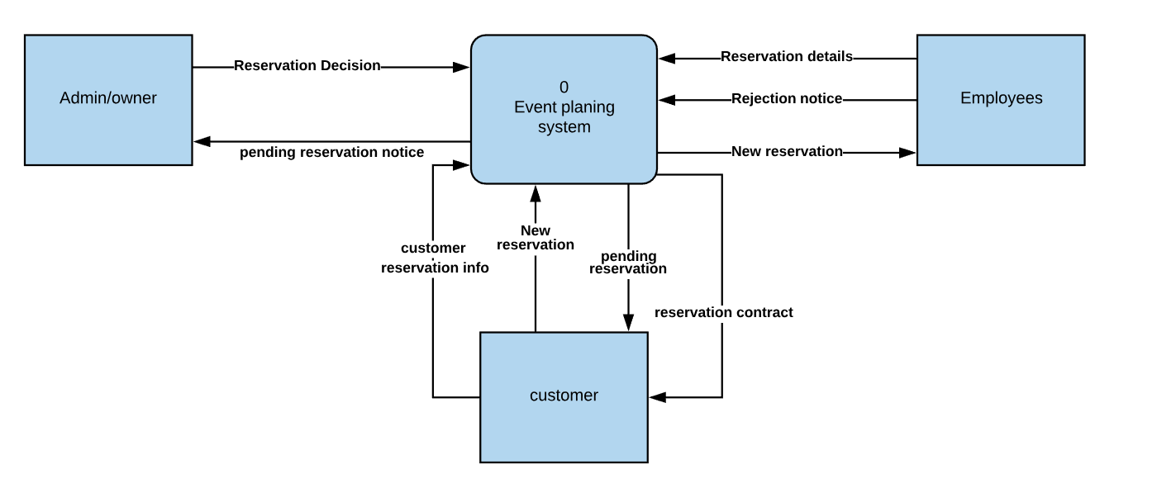

**LEVEL 0 DIAGRAM**

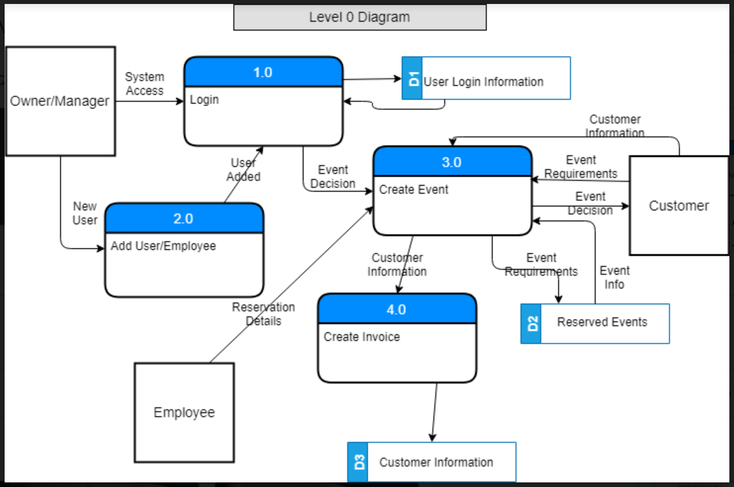

**LEVEL 1 DIAGRAMS**

**Process 1 Level 1 Diagram: Login**

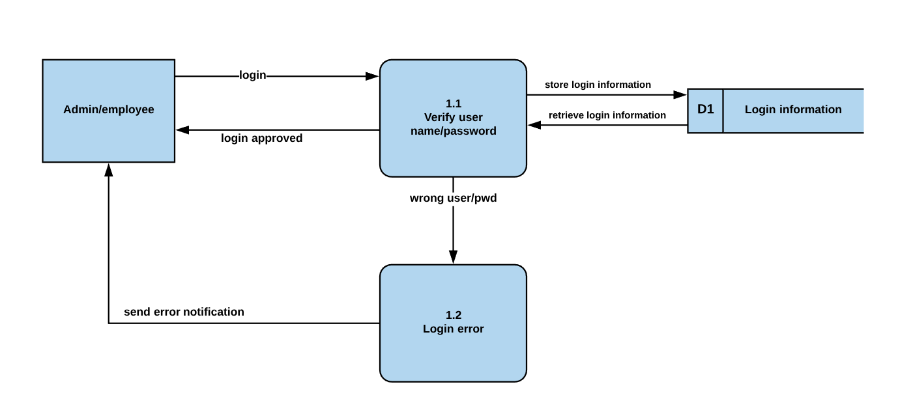

**Process 2 Level 1 Diagram: Add User/Employee**

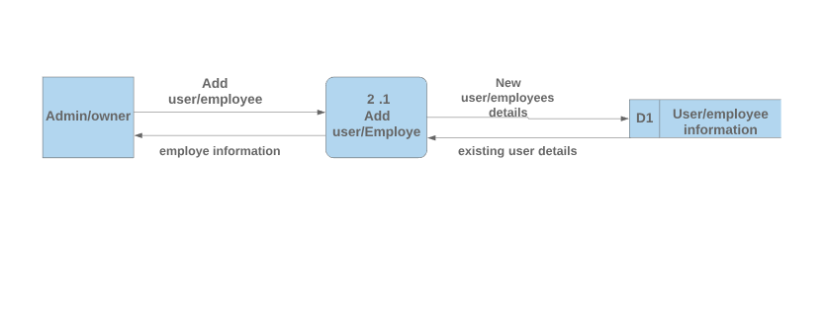

**Process 3 Level 1 Diagram: Create Event**

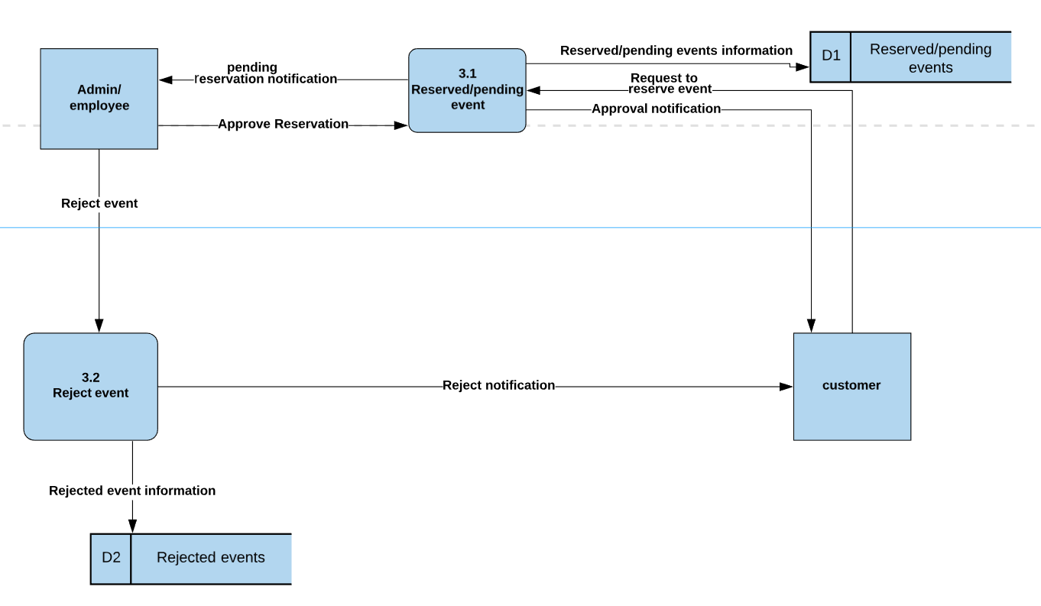

**Process 4 Level 1 Diagram: Create Invoice**

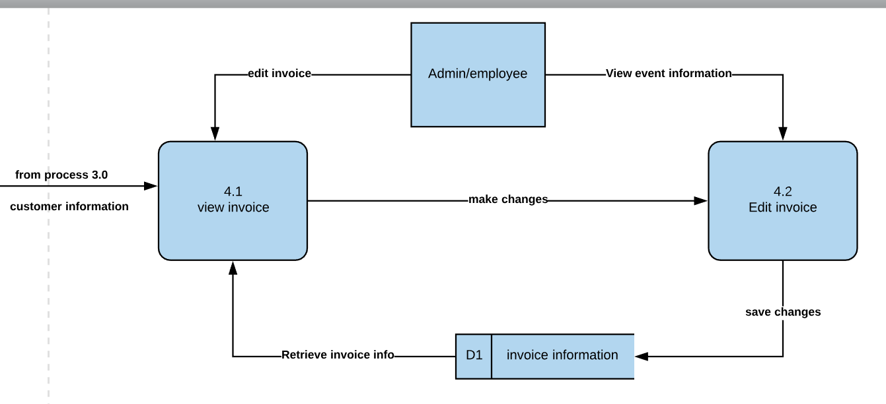

**LEVEL 2 DIAGRAM**

Process 3.1 Level 2 diagram

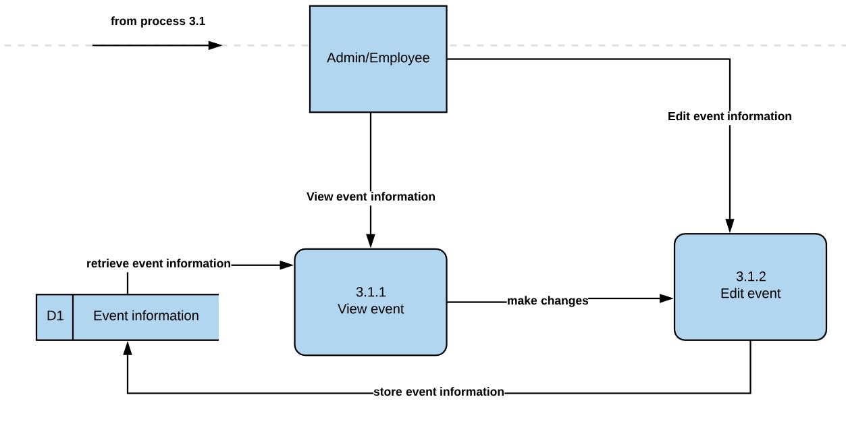

**CASE ENTRY OF PROCESS DESCRIPTION**

|  |  |
| --- | --- |
| Label | Process 1.0 |
| Entry Type | Process |
| Description | This is a description of level 1 Process |
| Process # | 1.1-verify username/pwd |
| Process Description | When Admin/Employee put username and Password, process 1.1 will check if the information is correct by retrieving login information from D1(login information) data store. If it is correct, it will send approval notification for the users and proceed to process 2.0. If it is not correct login information it will proceed to process 1.2(login error). |

|  |  |
| --- | --- |
| Label | Process 1.0 |
| Entry Type | Process |
| Description | This is a description of level 1 Process |
| Process # | 1.2-login error |
| Process Description | When it receives wrong user/password data flow from process 1.1, it will send an error notification to the user saying wrong username/password. |

|  |  |
| --- | --- |
| Label | Process 2.0 |
| Entry Type | Process |
| Description | This is a description of level 1 process |
| Process # | 2.1 - Add User/Employee |
| Process Description | The owner/manager enters new user information. The information can be used by the new user to login. Once the user logs in, the information is retrieved from the user/employee information data flow. If the username and password is valid, the user is granted access to the system, which leads to process 3.0. If the login fails, access to the system is denied and the user is return to Process 1.0, the login page. |

|  |  |
| --- | --- |
| Label | Process 3.0 |
| Entry Type | Process |
| Description | This is a description of level 1 process |
| Process # | 3.1 - Reserved/pending Event |
| Process Description | Once an event is created by a customer, the event is forwarded to the system. The employee can notify the manager of the new event created or the manager can view the new event created if he or she is logged into the system. The event created is compared against the event information data flow to check if there already exists an event on the requested date. If the event requirement is validated, then the event is approved and information sent back to the customer and the event information data flow is updated with the new event information and it moves to process 4.0 (create invoice).  If the event requirements cannot be met, a rejection notice is sent back to the customer and the process goes back to process 3.0 (create event). |

|  |  |
| --- | --- |
| Label | Process 3.0 |
| Entry Type | Process |
| Description | This is a description of level 1 process |
| Process # | 3.2 - Reject Event |
| Process Description | When an admin/employee get a reservation notification, admin/employe will check if the reservation requirements are valid. if it is valid it will send approval notification to process 3.1(reserve event), if not it will send rejection notification to process 3.2(reject event). 3.2 will send a notification to the customers saying event rejected and store rejected information at reject event data store. |

|  |  |
| --- | --- |
| Label | Process 3.1 |
| Entry Type | Process |
| Description | This is a description of level 2 process |
| Process # | 3.1.1 - View Event Info |
| Process Description | Receive reserved event information from 3.1(reserve event) and receive event records from the event information data store. Once it received the event information customers or admin/employees can view the events and it will move to 3.1.1 process (edit event). |

|  |  |
| --- | --- |
| Label | Process 3.1 |
| Entry Type | Process |
| Description | This is a description of level 2 process |
| Process # | 3.1.2 - Edit Event |
| Process Description | Once an event is reserved, reservation information flows to view event process and send the result to process 3.1.2(edit event) using make changes data flow. If Customers/employees/admin edit Event, it will store the edited data at the event information data store. |

|  |  |
| --- | --- |
| Label | Process 4.0 |
| Entry Type | Process |
| Description | This is a description of level 1 process |
| Process # | 4.1 - View Invoice |
| Process Description | Once an event is made, an invoice is created. The admin/employee can access an invoice through view invoice.This gives them the ability to review all information in the invoice. This information is being pulled from the invoice information data store as well as from process 3 where the customer information is populated. |

|  |  |
| --- | --- |
| Label | Process 4.0 |
| Entry Type | Process |
| Description | This is a description of level 1 process |
| Process # | 4.2 - Edit Invoice |
| Process Description | Once an event is made, an invoice is created. The admin/employee can access an invoice through view invoice. This gives them the ability to edit all information in the invoice. This information is being pulled from the invoice information data store as well as from process 3 where the customer information is populated, so if any of that is incorrect, the employee/admin can correct it. |

**Gantt Chart**

